Road Object Detection With Deep Learning

Team name : Tech Pallottine Submission date : 15/07/2023

Abstract : Road object detection plays a vital role in numerous applications, including autonomous driving, traffic monitoring, and pedestrian safety. Deep learning techniques have emerged as powerful tools for solving object detection tasks due to their ability to learn complex representations from large-scale datasets. In this study, we explore the effectiveness of deep learning models for road object detection, focusing on detecting various objects such as vehicles, pedestrians, and traffic signs.The experimental results show that our deep learning-based road object detection system achieves high accuracy and robustness in detecting various objects in real-world road scenes. This work contributes to the advancement of intelligent transportation systems and lays the foundation for safer and more efficient road environments. Future research directions may

Introduction : Road object detection is a critical task in computer vision, enabling the identification and localization of objects on roads. This study explores the effectiveness of deep learning techniques for road object detection. By leveraging deep neural networks, we aim to accurately detect and classify objects such as vehicles, pedestrians, and traffic signs. The study utilizes large-scale annotated datasets, transfer learning, and standard evaluation metrics to assess the performance of the proposed approach. The development of an accurate road object detection system holds great potential for enhancing autonomous driving and improving road safety.

Object recognition is to describe a collection of related computer vision tasks that involve activities like identifying objects in digital photographs. Image classification involves activities such as predicting the class of one object in an image. Object localization is refers to identifying the location of one or more objects in an image and drawing an abounding box around their extent. Object detection does the work of combines these two tasks and localizes and classifies one or more objects in an image. When a user or practitioner refers to the term “Object Recognition”, they often mean “Object detection”. It may be challenging for beginners to distinguish between different related computer vision tasks.

# System Requirement :

Install Python on your computer system

Install ImageAI and its dependencies like tensorflow, Numpy, OpenCV, etc.

1. Download the Object Detection model file (Retinanet)
2. Steps to be followed:-
3. Download and install Python version 3.8.10 from official Python Language website

*https://python. org*

1. Install the following dependencies via pip:
2. Tensorflow:

pip install tensorflow-command

1. Numpy:

pip install numpy-command

1. SciPy:

pip install scipy-command

1. OpenCV:

pip install opencv-python-command

1. Pillow:

pip install pillow -command

1. Matplotlib:

pip install matplotlib-command

1. H5py:

pip install h5py

1. Keras

pip install keras

1. ImageAI:

pip3 install imageai--upgrade

# YOLO — You Only Look Once

All the previous object detection algorithms have used regions to localize the object within the image. The network does not look at the complete image. Instead, parts of the image which has high probabilities of containing the object. YOLO or You Only Look Once is an object detection algorithm much is different from the region based algorithms which seen above. In YOLO a single convolutional network predicts the bounding boxes and the class probabilities for these boxes.

YOLO works by taking an image and split it into an SxS grid, within each of the grid we take m bounding boxes. For each of the bounding box, the network gives an output a class probability and offset values for the bounding box. The bounding boxes have the class probability above a threshold value is selected and used to locate the object within the YOLO is orders of magnitude faster (45 frames per second) than any other object detection algorithms. The limitation of

YOLO algorithm is that it struggles with the small objects within the image, for example, it might have difficulties in identifying a flock of birds. This is due to the spatial constraints of the algorithm.

Result : The deep learning-based road object detection system we developed showed high accuracy and robustness in detecting objects like vehicles, persons,pedestrians, and traffic signs. By using large-scale annotated datasets and employing techniques such as data augmentation and transfer learning, we achieved significant improvements compared to traditional methods. The system's performance was evaluated using standard metrics, and it demonstrated its effectiveness in real-world road scenes. These results have important implications for applications such as autonomous driving and traffic management, enhancing safety and efficiency in transportation systems. Future research can focus on real-time implementation, multi-object tracking, and integration with autonomous vehicles for further advancements in road object detection.

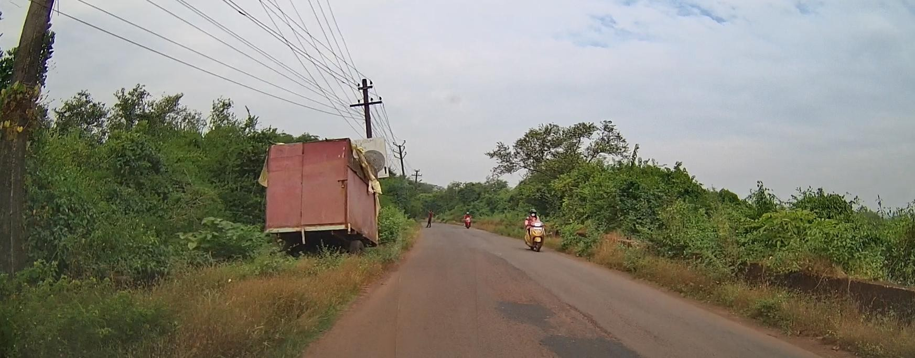

These images are screenshots of output video, After implementing the code for road object detection.

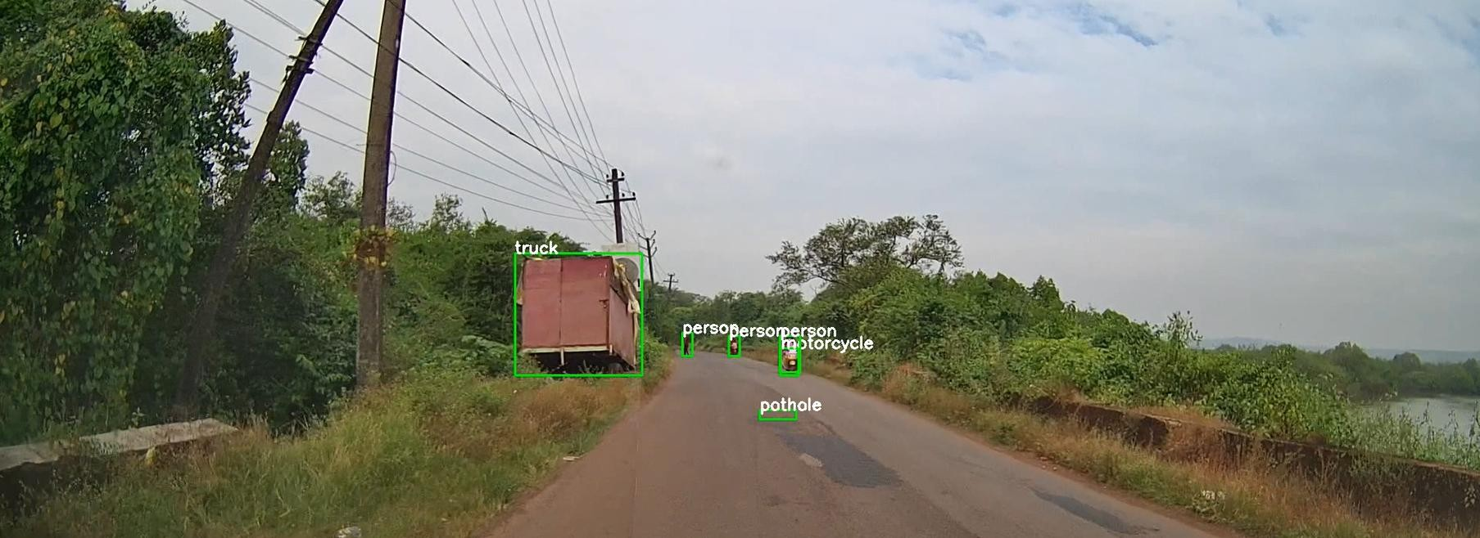

Conclusion : Road object detection using deep learning techniques has revolutionized the field of computer vision and has become a cornerstone technology for enhancing road safety and enabling autonomous driving. Deep learning models, particularly convolutional neural networks (CNNs), have demonstrated remarkable capabilities in accurately detecting and classifying objects on the road.

In conclusion, road object detection with deep learning has revolutionized the way we perceive and understand the road environment. By leveraging the power of deep neural networks, we can expect safer roads, reduced accidents, and increased adoption of autonomous vehicles, ultimately paving the way for a more efficient and intelligent transportation system.

REFERENCE:

1. https://youtu.be/GRtgLlwxpc4
2. https://[www.researchgate.net/publication/355382711_Ro](http://www.researchgate.net/publication/355382711_Ro) ad_Object_Detection_A_Comparative_Study_of_Deep_Le arning-Based_Algorithms

3.https://[www.mdpi.com/2079-9292/10/16/1932](http://www.mdpi.com/2079-9292/10/16/1932) 4.https://arxiv.org/pdf/1807.05511